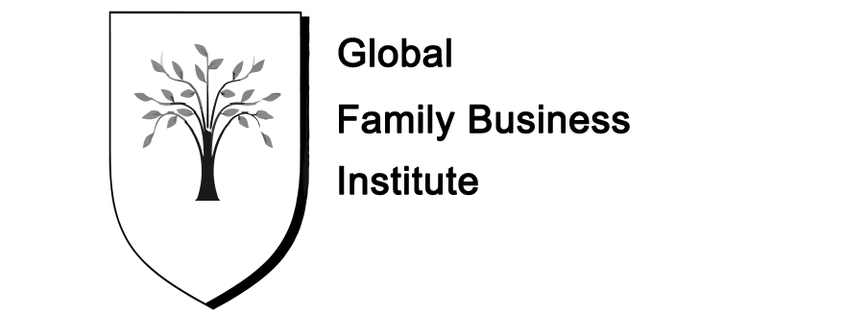

**Proposed Sponsorship Package:** There are 3 levels of sponsorship available and only 6 sponsors sought in 2016-2017.

**Sponsorship Levels: Price/calendar year Number of Sponsors**

Gold 500 Euros 1

Silver 300 Euros 2

Bronze 200 Euros 3

**Offering:**

***Gold level***. Font on web page is 14, logo on letterhead and on title slide of all power-point presentations; mention on all press releases; and last slide of presentations named as a sponsor

***Silver level.*** Font on web page is 12; logo on letterhead and name mention on last slide of presentations

***Bronze level.***  Font on web page is 10; logo on letterhead and name mention on last slide of presentations